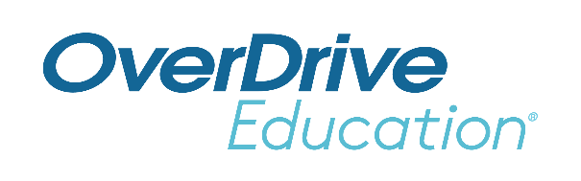
School Logo
FOR IMMEDIATE RELEASE

School Name’s New Reading App Provides 24/7 Access to Ebooks and Audiobooks
Award-winning Sora app encourages students to read anytime, anywhere

CITY, State or Region – Month Day, Year – As schools seek innovative new strategies to increase reading and learning, educators are shifting their curriculum to include more digital books in the classroom. Now, School name is expanding access to reading materials by connecting their students with the school’s broad collection of ebooks and digital audiobooks through the Sora app. [If students can access public library: Sora also connects seamlessly with (local library name)’s digital collection to provide access to even more age-appropriate digital books.] The combination of convenience and personalization – Sora enables access to both teacher-assigned and student-selected titles – inspires students to learn anytime, anywhere.
(School staff member quote about Sora/ebook access – excitement, expectations, etc.)
Through Sora, School name students have convenient and safe access to [hundreds OR thousands] of age-appropriate ebooks and digital audiobooks from the school’s [If applicable: as well as the public library’s] collection(s). These reading materials are available for use on any device inside the classroom, at home and anywhere 24/7. Educators across the country are using Sora to inspire more reading and improve learning outcomes.
Sora provides seamless access to both assigned and pleasure reading within the app, incentivizing learning through fun avatars and achievements. Sora also supports teachers by offering classroom-specific tools like personal assignments, reading analytics and exportable notes that individualize learning.
Sora, named one of TIME’s Best Inventions and the Excellence in Equity 2022 Best Literacy Solution, was built by OverDrive Education, a division of OverDrive serving tens of thousands of K-12 schools worldwide. OverDrive is the leading digital reading platform for a growing network of tens of thousands of libraries – including local Library name – and schools in over 100 countries.
The Sora app is available for School name students, faculty and staff to download through the Apple App Store and Google Play Store, and on Chromebooks that support the Google Play Store. It is also available for use in web browsers at https://soraapp.com.
To learn more, visit http://discoversora.com.

About School Name
Add boilerplate description

About OverDrive Education and the Sora student reading app
OverDrive Education, a division of OverDrive, offers the industry’s largest catalog of ebooks, audiobooks, digital magazines and other content for tens of thousands of K-12 schools and millions of students worldwide. The company's student reading app, Sora, provides every student with access to the right books. Sora was named one of TIME’s Best Inventions. TeachingBooks.net, acquired in 2021, complements Sora with one of the largest catalogs of original and curated literary resources. Founded in 1986, OverDrive – the leading digital reading platform for libraries – and OverDrive Education are in Cleveland, Ohio USA. www.overdrive.com/schools

Contact:
School contact name
School name
Phone number
Email address
###

