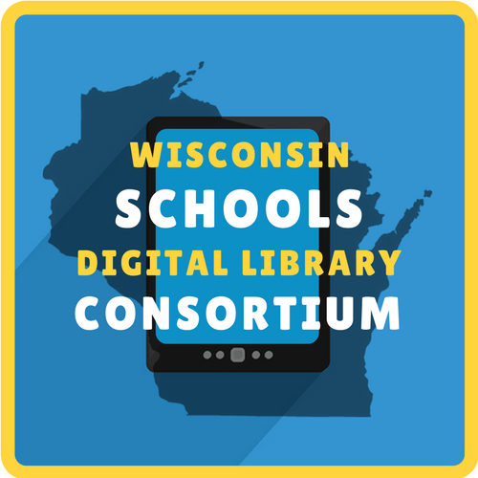
FREE EBOOKS & DIGITAL AUDIOBOOKS FOR YOUR STUDENT
ANYTIME, ANYWHERE

WHAT IS WSDLC?
Your school is committed to bringing unique literacy and learning opportunities to students. The WSDLC is a free reading service providing 24/7 access to digital books and audiobooks at https://soraapp.com/library/wsdlcwi.

WSDLC can help students of all ages read more and improve comprehension. Struggling or reluctant readers, learning-challenged, second language learners, and gifted readers can all benefit from this service. Use WSDLC to:

Enrich vocabulary and improve comprehension and pronunciation.
Introduce students to books above their reading level. Teach critical listening.
Help busy kids find time to read!

To start reading, visit https://soraapp.com/library/wsdlcwi
and [insert log in instructions for your school]

