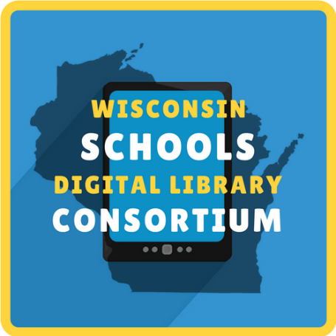
Hello, Teachers!
We are excited to share that students in your school have access to a collection of over 40,000 ebooks, digital audiobooks, magazines, and comic available 24/7 through the Wisconsin Schools Digital Library Consortium (WSDLC)! Whether students need study guides, required reading, or the latest popular fiction and nonfiction for children and young adults, they can find it all in the digital collection through WSDLC. Titles can also be identified by their ATOS Level, Lexile Measure, or grade level.
You can find the collection at https://soraapp.com/library/wsdlcwi.
Students log in by [insert access instructions].
The collection is powered by OverDrive. For help using it, visit the Sora Help Page or contact [local contact info].
If you’d like to know more about the WSDLC and the over 200 participating school districts, visit https://wsdlc.org/.

Hello, Teachers!
We are excited to share that students in your school have access to a collection of over 40,000 ebooks, digital audiobooks, magazines, and comic available 24/7 through the Wisconsin Schools Digital Library Consortium (WSDLC)! Whether students need study guides, required reading, or the latest popular fiction and nonfiction for children and young adults, they can find it all in the digital collection through WSDLC. Titles can also be identified by their ATOS Level, Lexile Measure, or grade level.
You can find the collection at https://soraapp.com/library/wsdlcwi.
Students log in by [insert access instructions].
The collection is powered by OverDrive. For help using it, visit the Sora Help Page or contact [local contact info].
If you’d like to know more about the WSDLC and the over 200 participating school districts, visit https://wsdlc.org/.

