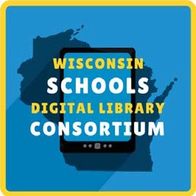
Getting Started with WSDLC
The Wisconsin Schools Digital Library Consortium provides students 24/7 access to over 40,000 ebooks, digital audiobooks, comics, and magazines. Here's how to get started!

Visit https://soraapp.com/library/wsdlcwi and select your school.
- Sign in by [insert access instructions].
- Read and listen!

Have any problems or questions? Contact [local contact info]

Getting Started with WSDLC
The Wisconsin Schools Digital Library Consortium provides students 24/7 access to over 40,000 ebooks, digital audiobooks, comics, and magazines. Here's how to get started!

Visit https://soraapp.com/library/wsdlcwi and select your school.
- Sign in by [insert access instructions].
- Read and listen!

Have any problems or questions? Contact [local contact info]

