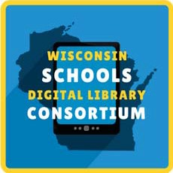
Getting Started with WSDLC
The Wisconsin Schools Digital Library Consortium provides students 24/7 access to over 40,000 ebooks and digital audiobooks, comics, and magazines. Here's how to get started!
- Visit https://soraapp.com/library/wsdlcwi and select your school.
- Sign in by [insert access instructions].
- Read and listen!
Have any problems or questions? Contact [local contact info]

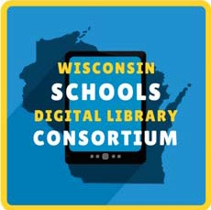
Getting Started with WSDLC
The Wisconsin Schools Digital Library Consortium provides students 24/7 access to over 40,000 ebooks and digital audiobooks, comics, and magazines. Here's how to get started!
Visit https://soraapp.com/library/wsdlcwi and select your school.
- Sign in by [insert access instructions].
- Read and listen!
Have any problems or questions? Contact [local contact info]

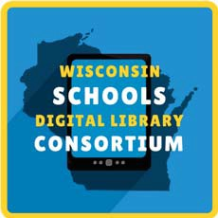
Getting Started with WSDLC
The Wisconsin Schools Digital Library Consortium provides students 24/7 access to over 40,000 ebooks and digital audiobooks, comics, and magazines. Here's how to get started!
Visit https://soraapp.com/library/wsdlcwi and select your school.
- Sign in by [insert access instructions].
- Read and listen!
Have any problems or questions? Contact [local contact info]

Getting Started with WSDLC
The Wisconsin Schools Digital Library Consortium provides students 24/7 access to over 40,000 ebooks and digital audiobooks, comics, and magazines. Here's how to get started!
Visit https://soraapp.com/library/wsdlcwi and select your school.
- Sign in by [insert access instructions].
- Read and listen!
Have any problems or questions? Contact [local contact info]

Getting Started with WSDLC
The Wisconsin Schools Digital Library Consortium provides students 24/7 access to over 40,000 ebooks and digital audiobooks, comics, and magazines. Here's how to get started!
Visit https://soraapp.com/library/wsdlcwi and select your school.
- Sign in by [insert access instructions].
- Read and listen!
Have any problems or questions? Contact [local contact info]

