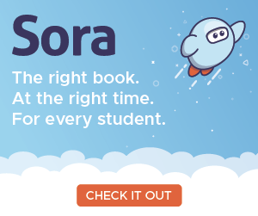
October 10, 2018
Dear Parents and Teachers,

OverDrive - Sora is available for the School District of Cambridge Students

Cambridge students and teachers can access e-books and audio books by logging into their Chromebooks or by using the Chrome browser on any computer. If they have access to a SMART Phone they can download the Sora app, by OverDrive. If they have a Kindle they can download the ebook to a Kindle.

The Sora by OverDrive app - is a great resource for ebooks and audiobooks. In order to increase our buying power for ebooks, the School District of Cambridge joined the Wisconsin Schools Digital Library Consortium. By pooling our money, we are able to buy more ebooks to offer our students.

Sample Books | How to Access the Books
Elementary  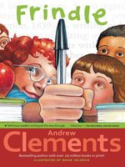  Middle School  High School | Go to the District’s Webpage.  https://www.cambridge.k12.wi.us/  For Cambridge Elementary and Nikolay Middle Schools. Go to Family Resources and select OverDrive – Sora.  For Cambridge High School go to the Student/Parent Resources and hover over IMC > then select OverDrive - Sora  To access Sora see Sora by OverDrive Login Info & Use  Checkout options:  - Limit is 3 books/student.  - Time limit is 14 days per book  - Option to renew unless a Hold on the book has been placed.  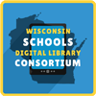

In order to motivate students to higher achievement, the School District of Cambridge is growing Digital Content not only through the OverDrive – Sora resource but also through your school’s Library Online Catalog, Destiny,

Every child wonders and seeks independence in learning. These digital resources encourage reading and meet the needs of all reading levels.

Each school also has access to websites that link students to research links through the Destiny Home Page. http://destiny.cambridge.k12.wi.us/ . You can click on your child’s school and see a list of websites on the Destiny Homepage. You can click on the Catalog tab to locate books and websites on a topic. Webpath Express is a motivating tool to browse teacher selected and content approved websites. You can also enter a topic in the keyword box and click on One Search in order to locate information from BadgerLink.

Sora by OverDrive Login Info & Use
From the Sora Webpage click on My school is Wisconsin Schools Digital Library Consortium

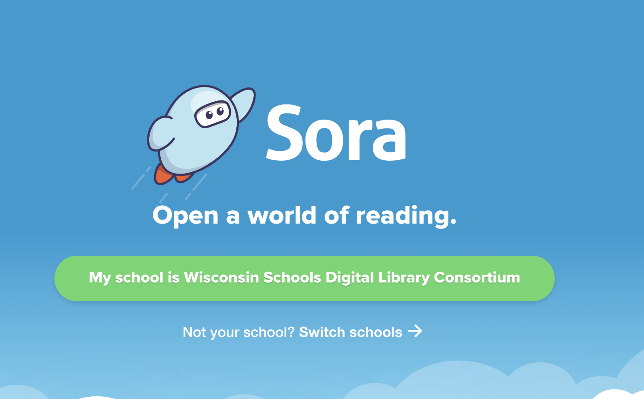

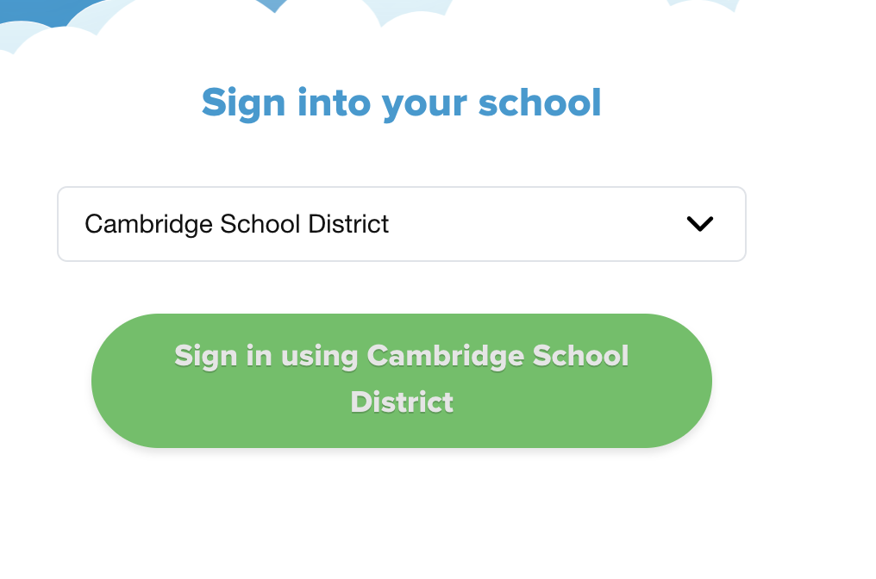
Scroll to Cambridge School District and click on Sign in Using Cambridge School District

If your child’s email does not appear automatically, type his/her email address in.
When this screen appears click on Explore

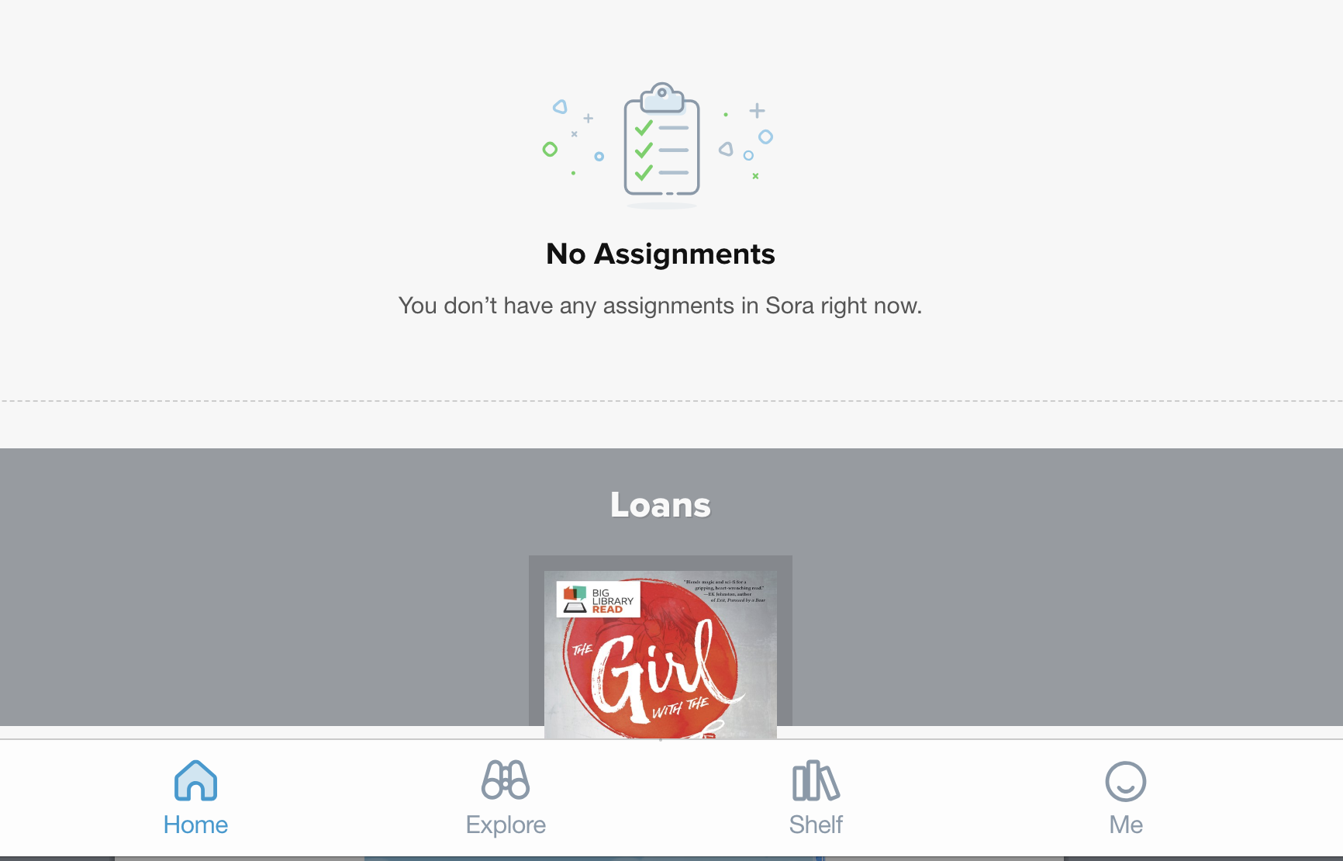

You can Search for a book or browse the library by collections.

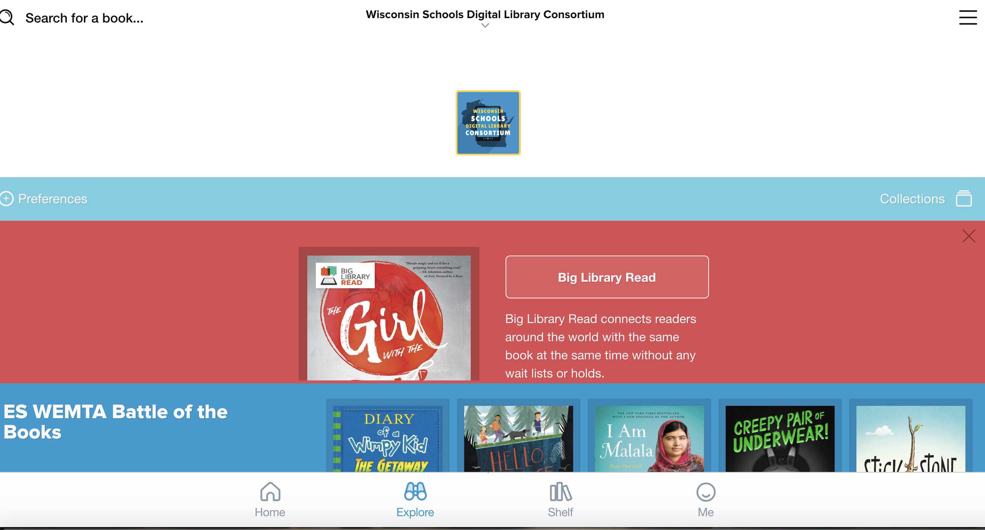

The next screen shot shows the Collections screen. Children love to have choices in reading and this is one way to see various choices. If your child wants to locate the audio books available click on New audiobook additions.
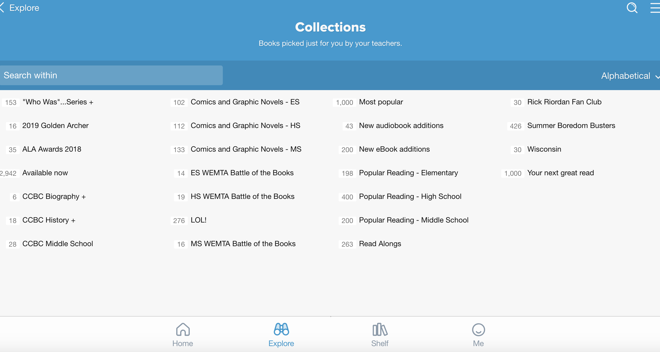

Find a book that looks interesting and click on Borrow
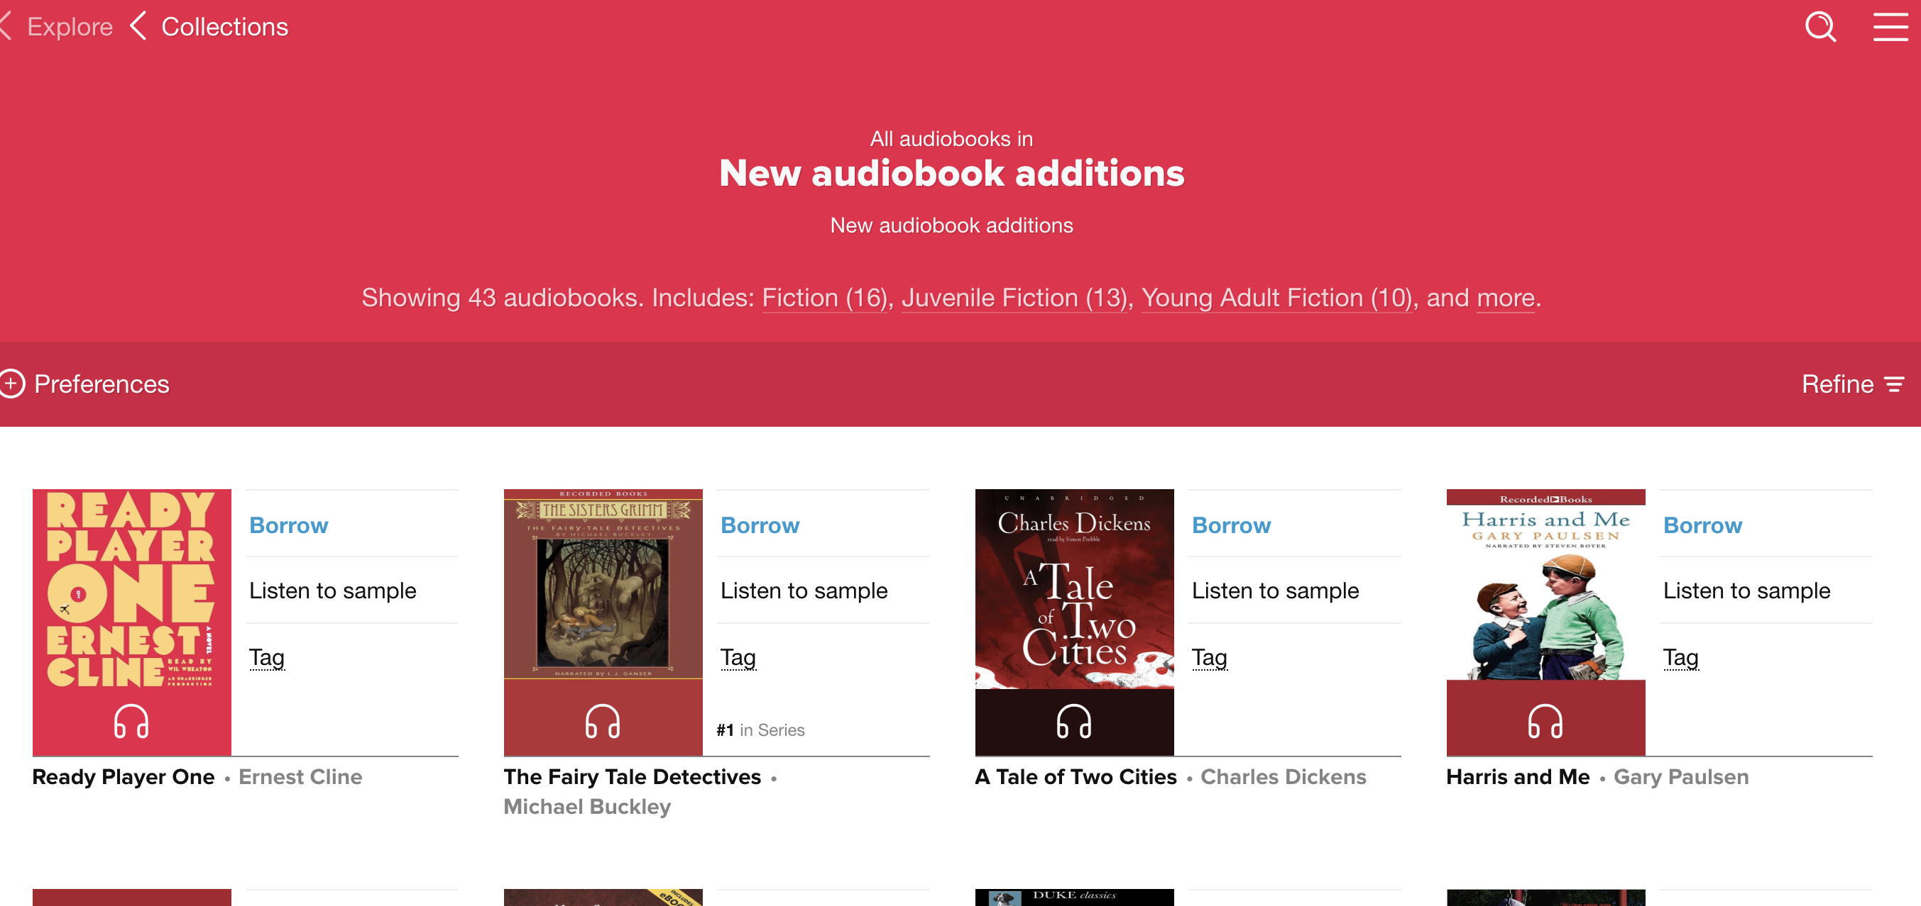

The book goes onto your child’s Shelf. Your child can have 3 books checked out. Each book can be borrowed for 2 weeks. The books automatically return after two weeks if your child does not click Return.

Your child can return the book ahead of time by clicking on Close in left corner.
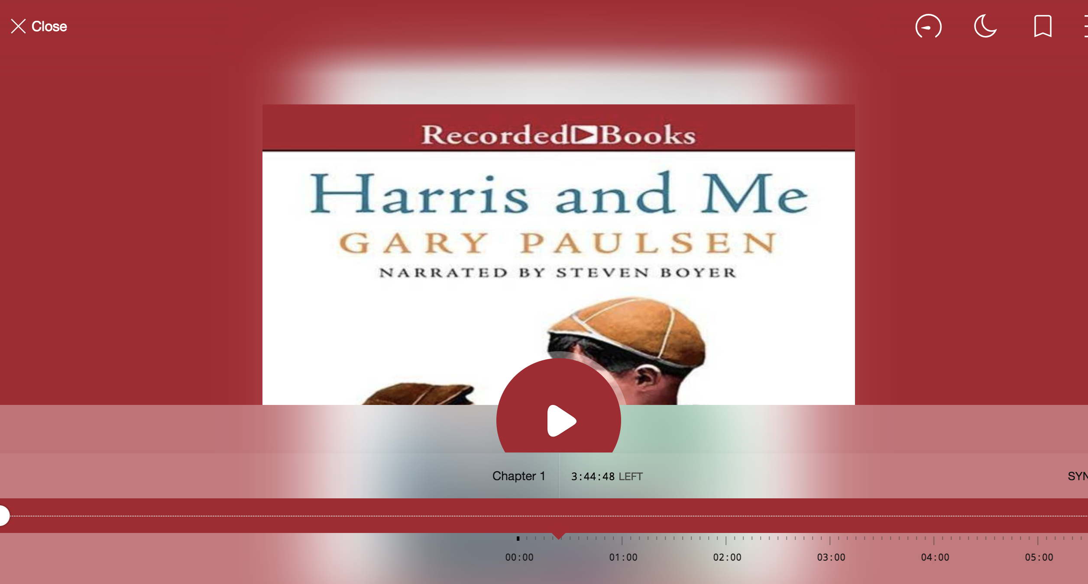

Then click on Return
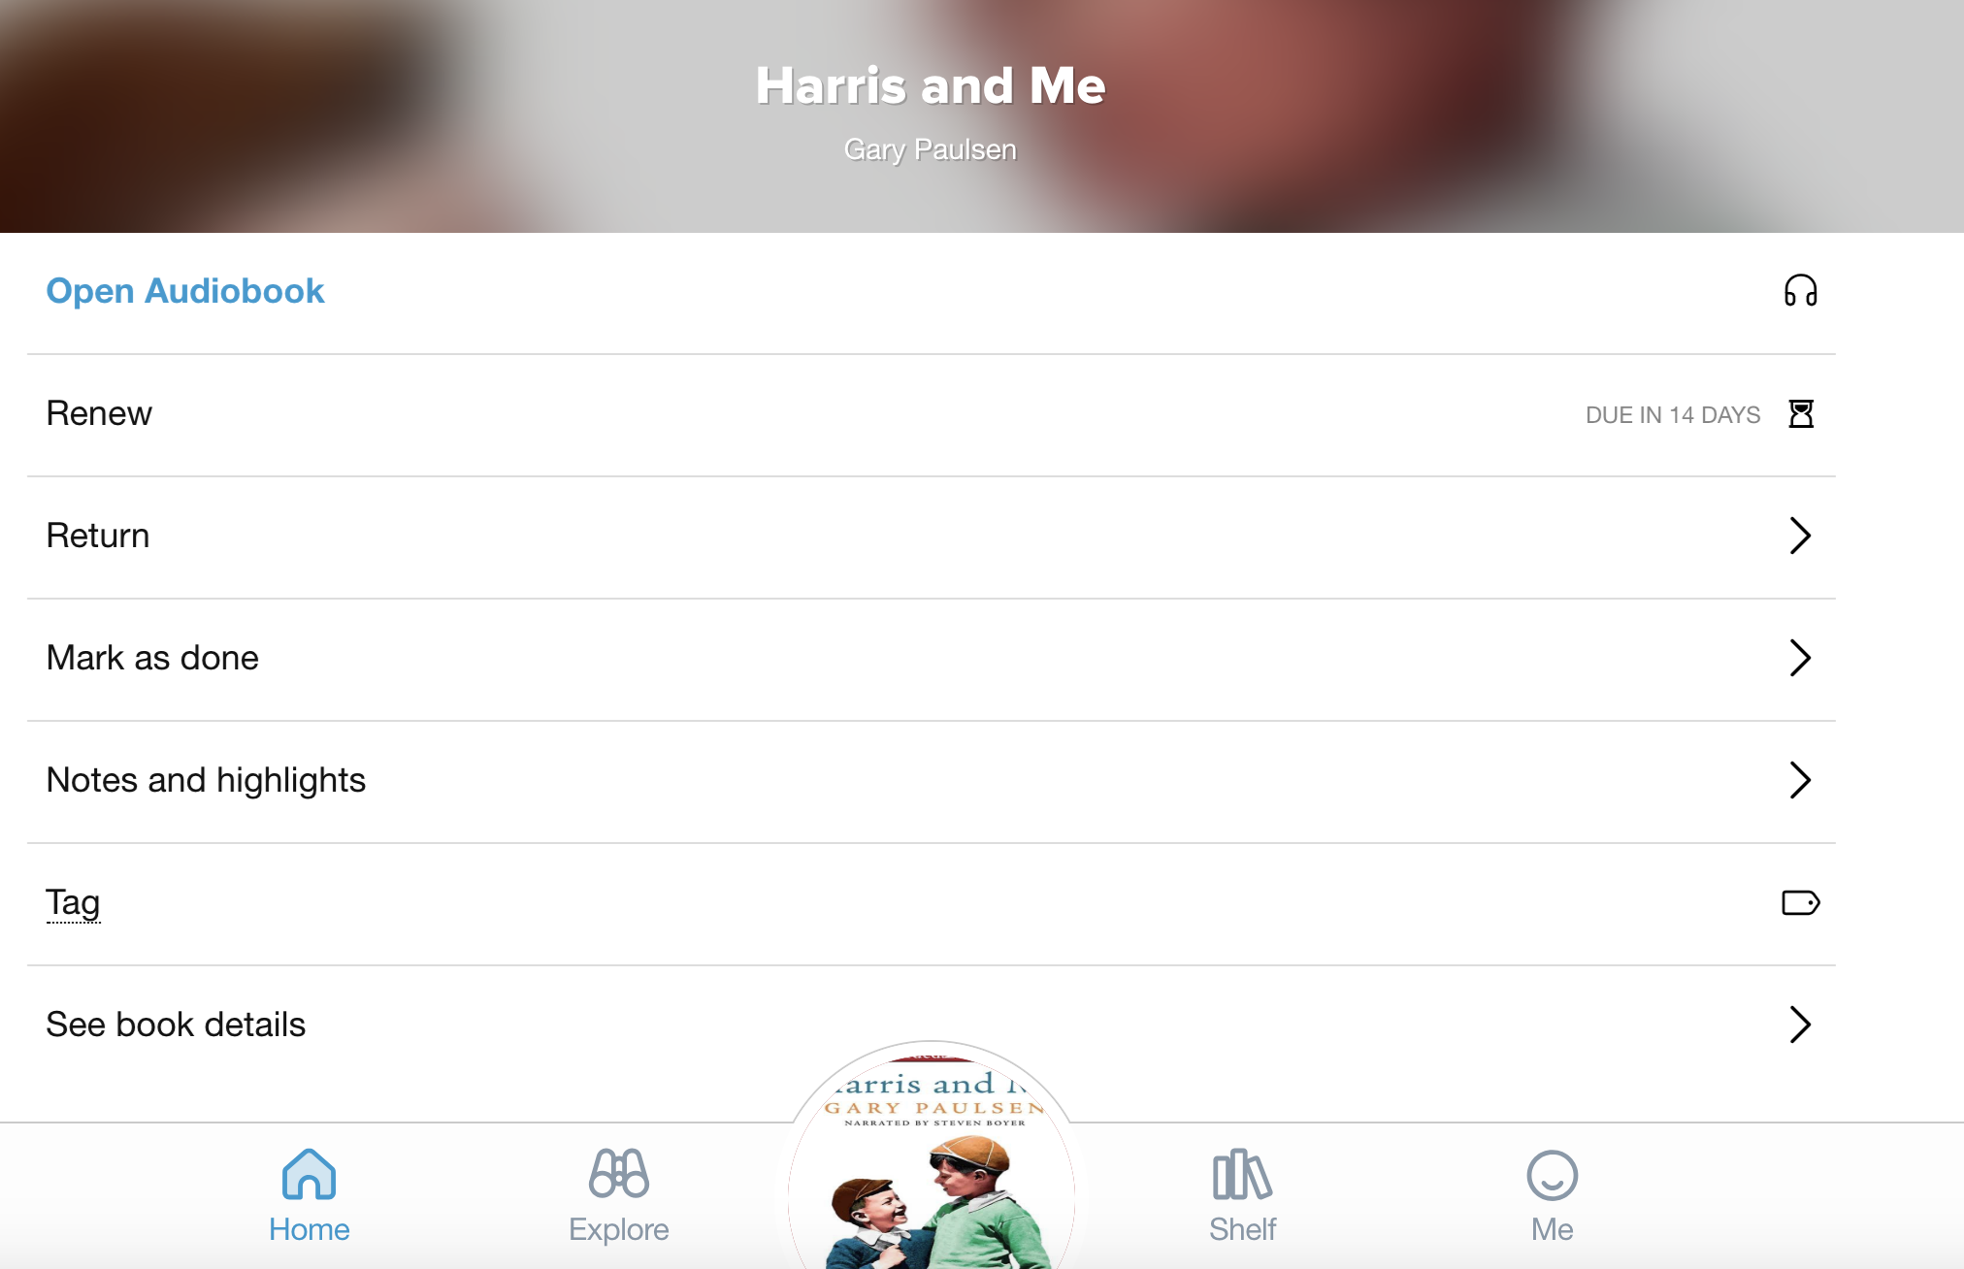

There are so many reading activity enhancements that your child can do using Sora. Your child can:
- Highlight words,
- Look up the definition of that highlighted word, and
- Take notes. The notes can be exported from the app to a PDF File to share with the teacher.
- Sora also personalizes your child’s reading achievements by keeping track of reading minutes and badges of achievements.

SORA tips will be coming soon

Please feel free to contact me via email if you have comments and questions.

Kathy Boguszewski
Library Media Consultant
kboguszewski@cambridge.k12.wi.us

